Risnjak C:\Users\skoo\AppData\Local\Microsoft\Windows\Temporary Internet Files\Content.IE5\VK9UTQJR\MC900432401[1].wmf

Krenuli smo autobusom iz Pule.

U autobusu je bilo zabavno.

Na Risnjaku je bilo oblačno, ali nije padala kiša.

Gospodin Dragan bio je naš vodič kroz šumu.

Pričao nam je o biljkama i životinjama Risnjaka.

U šumi smo vidjeli: C:\Users\skoo\AppData\Local\Microsoft\Windows\Temporary Internet Files\Content.IE5\W4399JD1\MC900191661[1].wmf, 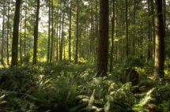 , 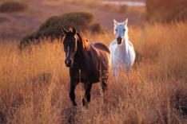 i 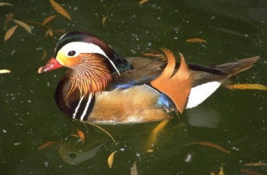 .

Nismo vidjeli: C:\Users\skoo\AppData\Local\Microsoft\Windows\Temporary Internet Files\Content.IE5\W4399JD1\MC900024562[1].wmf, C:\Users\skoo\AppData\Local\Microsoft\Windows\Temporary Internet Files\Content.IE5\0AQDHTCO\MC900441392[1].wmf, C:\Users\skoo\AppData\Local\Microsoft\Windows\Temporary Internet Files\Content.IE5\0AQDHTCO\MC900192317[1].wmfni C:\Users\skoo\AppData\Local\Microsoft\Windows\Temporary Internet Files\Content.IE5\W4399JD1\MC900052976[1].wmf.

C:\Users\skoo\AppData\Local\Microsoft\Windows\Temporary Internet Files\Content.IE5\VK9UTQJR\MC900052600[1].wmf i 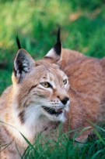 smo vidjeli samo na filmu.